**Hello World RESTful Web Service**   
  
**CODE**:

package com.cognizant.springlearn;  
  
import org.slf4j.Logger;  
import org.slf4j.LoggerFactory;  
  
public class Country {  
 private static final Logger *LOGGER* = LoggerFactory.*getLogger*(Country.class);  
  
 private String code;  
 private String name;  
  
 public Country() {  
 *LOGGER*.debug("Inside Country Constructor.");  
 }  
  
 public String getCode() {  
 *LOGGER*.debug("Inside getCode()");  
 return code;  
 }  
  
 public void setCode(String code) {  
 *LOGGER*.debug("Inside setCode()");  
 this.code = code;  
 }  
  
 public String getName() {  
 *LOGGER*.debug("Inside getName()");  
 return name;  
 }  
  
 public void setName(String name) {  
 *LOGGER*.debug("Inside setName()");  
 this.name = name;  
 }  
  
 @Override  
 public String toString() {  
 return "Country [code=" + code + ", name=" + name + "]";  
 }  
}

package com.cognizant.springlearn.controller;  
  
import org.slf4j.Logger;  
import org.slf4j.LoggerFactory;  
import org.springframework.web.bind.annotation.GetMapping;  
import org.springframework.web.bind.annotation.RestController;  
  
@RestController  
public class HelloController {  
 private static final Logger *LOGGER* = LoggerFactory.*getLogger*(HelloController.class);  
  
 @GetMapping("/hello")  
 public String sayHello() {  
 *LOGGER*.info("START - sayHello()");  
 String message = "Hello World!!";  
 *LOGGER*.info("END - sayHello()");  
 return message;  
 }  
}

package com.cognizant.springlearn;  
  
import org.slf4j.Logger;  
import org.slf4j.LoggerFactory;  
import org.springframework.boot.SpringApplication;  
import org.springframework.boot.autoconfigure.SpringBootApplication;  
import org.springframework.context.ApplicationContext;  
import org.springframework.context.support.ClassPathXmlApplicationContext;  
  
  
@SpringBootApplication  
public class SpringLearnApplication {  
 private static final Logger *LOGGER* = LoggerFactory.*getLogger*(SpringLearnApplication.class);  
  
 public static void main(String[] args) {  
 *LOGGER*.info("START");  
  
 SpringApplication.*run*(SpringLearnApplication.class, args);  
 *displayCountry*();  
  
 *LOGGER*.info("END");  
 }  
  
 public static void displayCountry() {  
 ApplicationContext context = new ClassPathXmlApplicationContext("country.xml");  
 Country country = context.getBean("country", Country.class);  
 *LOGGER*.debug("Country : {}", country.toString());  
 }  
}

**OUTPUT:**

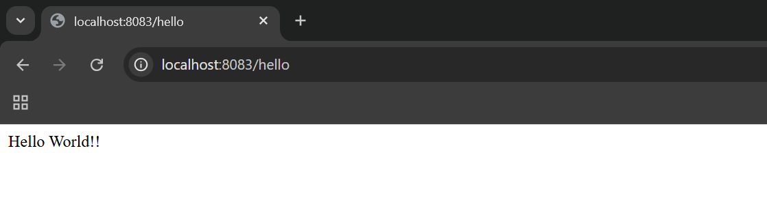

**REST - Get country based on country code** 

**CODE**:

country.xml:

<?xml version="1.0" encoding="UTF-8"?>  
<beans xmlns="http://www.springframework.org/schema/beans"  
 xmlns:xsi="http://www.w3.org/2001/XMLSchema-instance"  
 xsi:schemaLocation="  
 http://www.springframework.org/schema/beans  
 http://www.springframework.org/schema/beans/spring-beans.xsd">  
  
 <!-- Single bean for displayCountry() -->  
 <bean id="country" class="com.cognizant.springlearn.Country">  
 <property name="code" value="IN" />  
 <property name="name" value="India" />  
 </bean>  
  
 <!-- List of countries for REST API -->  
 <bean id="countryList" class="java.util.ArrayList">  
 <constructor-arg>  
 <list>  
 <bean class="com.cognizant.springlearn.Country">  
 <property name="code" value="US" />  
 <property name="name" value="United States" />  
 </bean>  
 <bean class="com.cognizant.springlearn.Country">  
 <property name="code" value="DE" />  
 <property name="name" value="Germany" />  
 </bean>  
 <bean class="com.cognizant.springlearn.Country">  
 <property name="code" value="IN" />  
 <property name="name" value="India" />  
 </bean>  
 <bean class="com.cognizant.springlearn.Country">  
 <property name="code" value="JP" />  
 <property name="name" value="Japan" />  
 </bean>  
 </list>  
 </constructor-arg>  
 </bean>  
</beans>

CountryService.java:

package com.cognizant.springlearn.service;  
  
import com.cognizant.springlearn.Country;  
import org.slf4j.Logger;  
import org.slf4j.LoggerFactory;  
import org.springframework.context.ApplicationContext;  
import org.springframework.context.support.ClassPathXmlApplicationContext;  
import org.springframework.stereotype.Service;  
  
import java.util.List;  
  
@Service  
public class CountryService {  
 private static final Logger *LOGGER* = LoggerFactory.*getLogger*(CountryService.class);  
 public Country getCountry(String code) {  
 *LOGGER*.info("START - getCountry() with code: {}", code);  
 ApplicationContext context = new ClassPathXmlApplicationContext("country.xml");  
 List<Country> countryList = context.getBean("countryList", List.class);  
 Country result = countryList.stream()  
 .filter(c -> c.getCode().equalsIgnoreCase(code))  
 .findFirst()  
 .orElse(null);  
  
 *LOGGER*.info("END - getCountry()");  
 return result;  
 }  
}

CountryController.java

package com.cognizant.springlearn.controller;  
  
import com.cognizant.springlearn.Country;  
import com.cognizant.springlearn.service.CountryService;  
import org.slf4j.Logger;  
import org.slf4j.LoggerFactory;  
import org.springframework.beans.factory.annotation.Autowired;  
import org.springframework.web.bind.annotation.GetMapping;  
import org.springframework.web.bind.annotation.PathVariable;  
import org.springframework.web.bind.annotation.RestController;  
  
  
@RestController  
public class CountryController {  
  
 private static final Logger *LOGGER* = LoggerFactory.*getLogger*(CountryController.class);  
  
 @Autowired  
 private CountryService countryService;  
  
 @GetMapping("/country/{code}")  
 public Country getCountry(@PathVariable String code) {  
 *LOGGER*.info("START - getCountry()");  
 Country country = countryService.getCountry(code);  
 *LOGGER*.info("END - getCountry()");  
 return country;  
 }  
}

application.properties:

spring.application.name=spring-learn  
  
server.port=8083  
logging.level.com.cognizant.springlearn=DEBUG

**SpringLearnApplication:**

package com.cognizant.springlearn;  
  
import org.slf4j.Logger;  
import org.slf4j.LoggerFactory;  
import org.springframework.boot.SpringApplication;  
import org.springframework.boot.autoconfigure.SpringBootApplication;  
import org.springframework.context.ApplicationContext;  
import org.springframework.context.support.ClassPathXmlApplicationContext;  
  
  
@SpringBootApplication  
public class SpringLearnApplication {  
 private static final Logger *LOGGER* = LoggerFactory.*getLogger*(SpringLearnApplication.class);  
  
 public static void main(String[] args) {  
 *LOGGER*.info("START");  
  
 SpringApplication.*run*(SpringLearnApplication.class, args);  
 *displayCountry*();  
  
 *LOGGER*.info("END");  
 }  
  
 public static void displayCountry() {  
 ApplicationContext context = new ClassPathXmlApplicationContext("country.xml");  
 Country country = context.getBean("country", Country.class);  
 *LOGGER*.debug("Country : {}", country.toString());  
 }  
}

**OUTPUT**:

